LAB BASED PROJECT REPORT

On

Anti-Aliasing Filter

Submitted in partial fulfilment of the

Requirements for the award of degree

**Bachelor of Technology**

In

Electronics and Communication Engineering

Submittted

By

N.SATISH - 180040132

T.VENKATA TEJA - 180040135

B.S.D.RAM PRASD - 180040136

Under the guidance of

Xxxxxxxxxxxxxxxxx

(Assistant Profesor)



**DEPARTMENT OF ELECTRONICS AND COMMUNICATION ENGINEERING**

**KONERU LAKSHMAIAH EDUCATIONAL FOUNDATION**

Green Fields, Vaddeswaram, Guntur District





CERTIFICATE

This is to certify that the project entitled **“Anti-Aliasing Filter”**,beingsubmitted by **“N.SATISH – 180040132, T.VENKATA TEJA -180040135, B.S.D.RAM PRASAD-180040136”** in partial fulfillment for the award of degree of **Bachelor of Technology (B.Tech)** in Electronics and Communications Engineering is a record of confide work carried outby them under our guidance during the academic year **2019-2020**and it has been foundworthy of acceptance according to the requirements of the university.

Signature of the Project Guide Signature of Head of Department

Department of ECE

**K L E F**

**KONERU LAKSHMAIAH EDUCATIONAL FOUNDATION**

**DEPARTMENT OF ELECTRONICS & COMMUNICATION ENGINEERING**



*DECLARATION*

we here by declare that this project based lab report entitled “ **Anti – aliasing Filter**” has been prepared by us in partial fulfillment of the requirement for the award ofdegree **“BACHELOR OF TECHNOLOGY IN ELECTRONICS AND COMMUNICATIONS OF ENGINEERING”** during the academic year 2019-2020.

we also declare that this project based lab report is of our own effort and it has not been submitted to any other university for the award of any degree.

**Acknowledgement**

We are greatly indebted to our KL University that has provided a healthy environment to drive us to achieve our ambitions and goals. We would like to express our sincere thanks to our project incharge Mr.**xxxxxxxxxxx**(Assistant professor) sir for the guidance, support and assistance they have provided in completing this project.

With immense pleasure, we would like to thank the Head of the Department, **Dr.M.Suman** sir for his valuable suggestions and guidance for the timely completion ofthis project.

We are very much glad for having the support given by our principal, **K. Subba Rao** sir who inspired us with his words filled with dedication and discipline towards work.

We believe that “**Practical Leads A Man Towards Performance**”.

Last but not the least, a special thanks goes to the Parents, staff and classmates who are helpful either directly or indirectly in completion of the Lab Based project

CONTENTS

Abstract

Introduction

Aliasing in General

Spatial Aliasing in Image

Anti-Aliasing in an Image

Gaussian Low Pass Filter

Median Filter

Matlab codes

Conclusion

References

Project Title: **Anti –Aliasing Fliter**

**ABSTRACT**

**Anti**-**aliasing filters** used to exclude mixing spectra in systems with digital signal processing. Electric power converters, especially active power **filters**, with digital control system are hard real-time systems. Such systems apply additional restrictions to the response of **anti**-**aliasing filters**.

INTRODUCTION

In this project, it was aimed to get rid of aliasing problem for an image using

anantialiasing filter before sampling procedure. To implement this filter, aliasing is generated inMATLAB software which will be discussed in this report. Different types of filters are applied tothe image and the best one is determined after some experiments. These filters are also discussedin this report in terms of their advantages and disadvantages.

**Aliasing in General**

To be able to understand the concept of aliasing, sampling procedure should be analyzed before discussing this concept. During sampling procedure, samples are taken from an analogsignal with a sampling rate. Aliasing concept is totally depends on this sampling rate. If thesampling rate is not sufficient, aliasing problem occurs during the reconstruction of the sampledsignal while converting the digital signal into the analog signal.According to Nyquist’s sampling theorem, sampling rate must be at least twice of the bandwidth of the analog signal at the beginning of sampling procedure to be able to reconstructthe sampled signal. In other words, if the analog signal is a periodic signal, at least two pointsmust be sampled in one period.

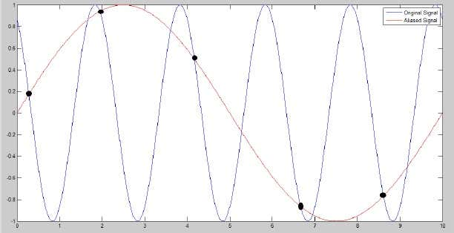

**Aliasing Problem in General**

In figure , aliasing problem for a periodic signal is illustrated. As seen in this figure,there are not taken two sample points in one period which causes the aliasing problem during reconstruction.

 If the original signal is not periodic, its frequency spectrum should be analyzed. In figure, this case is examined. As seen in figure , if the sampling rate is smaller than the Nyquist frequency, high frequency components in the original signal could not be reconstructed as they crosses the low frequency components of its replicas which are created during sampling procedure. For this situation not to happen, sampling rate must be at least Nyquist frequency.

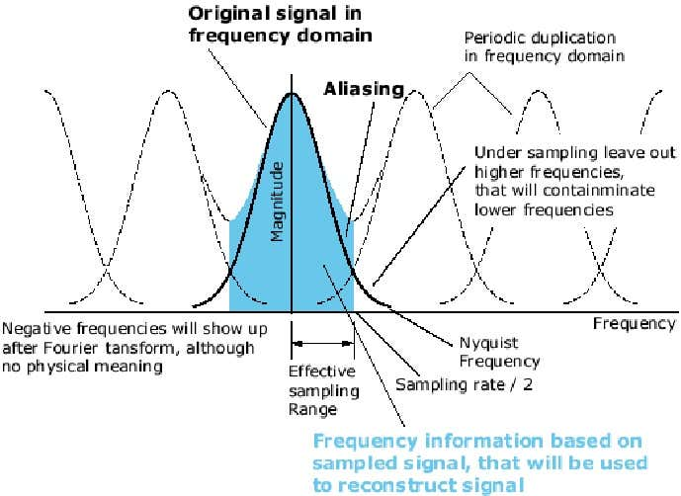

**FrequencySpectrum Analysis of Aliasing**

**Spatial Aliasing in Images**

**Spatial aliasing in images is not much different from the aliasing concept in general. Ananalog image has a frequency spectrum as well but there are two frequency axes because animage simply has two dimensions. During sampling of an analog image, the spatial frequencyspectrum of the image is duplicated at the spatial sampling frequencies of the axes. This situationis illustrated in figure .**

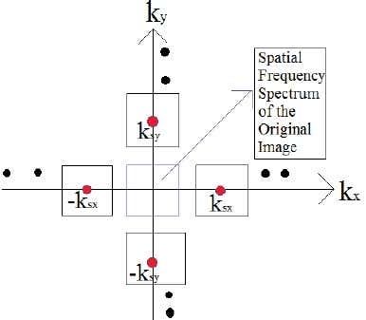

**Spatial Frequency Spectrum of an Image after Sampling**

**If the spatial sampling frequency rate of a dimension is not sufficient, aliasing occurs inthis dimension of the image because the spatial frequency spectrum of the original signal crossesits replicas at higher spatial frequencies of this dimension. The mentioned situation is illustratedin figure where sampling spatial frequency at x dimension is not enough to prevent aliasing.**

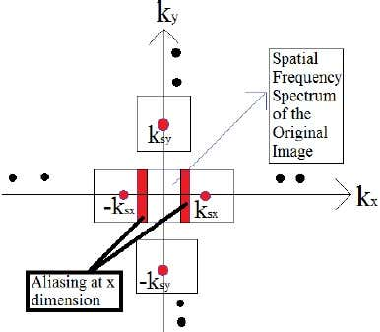

**Spatial Frequency Spectrum Analysis of Aliasing in an Image after Sampling**

**Anti-aliasing in an Image**

**Anti-aliasing concept means the application of filters to the images to prevent the aliasing problem caused by low spatial sampling rate. These filters remove high frequency components inthe image meaning that it reduces the bandwidth of the original image. To be able to examine thisconcept, an aliased image and the anti-aliased version of this image are obtained from an Internetsource which is given in the references section of this report. Fast Fourier transforms of bothimages are analyzed using MATLAB software.**

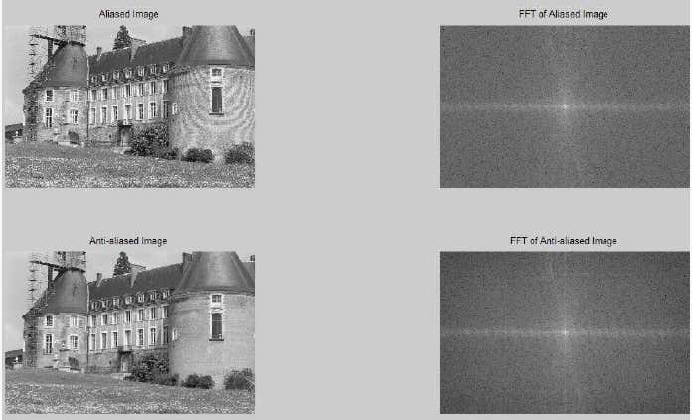

**Analysis of Anti-aliasing by the Examination of FFT of the Images**

**In figure , these images and their FFTs are shown. In the FFT of aliased image, lowfrequency components are darker than the FFT of anti-aliased image. By applying a suitable low pass filter, low frequency components are increased but higher frequency components aredecreased meaning that the filter suppresses the higher frequency components. When we comparethe higher frequency components of anti-aliased image to the lower frequency components of anti-aliased image, difference in the intensity is higher than the intensity in the aliased image.Since the aliasing occurs at higher frequency components due to the fact that replicas of theoriginal image created by sampling in spatial frequency domain cross the original image at higher frequencies, aliased image has a distortion at higher frequencies as seen in the figure.**

**Anti-Aliasing Filter Design**

**Since the aliasing is caused by high spatial frequency components as discussed in the previous sections, the bandwidth of the image should be limited in low spatial frequency components by using low pass filters. Thus, the type of the anti-aliasing filter should be a low pass filter. The type of low pass filter is to be determined after trying them for the same anti-aliased image. In this project, three types of low pass filters are tested and they are Gaussian low pass filter, Median filter and Butterworth low pass filter.**

**Gaussian Low Pass Filter**

**Gaussian low pass filter is a Gaussian distributed filter which allows low spatial frequency components to pass in the spatial frequency domain. In other words, it suppresses the high spatial frequency components with the Gaussian distribution. Gaussian low pass filters with 5 different cutoff frequencies are applied to the aliased image and the results are shown in the following figures.**

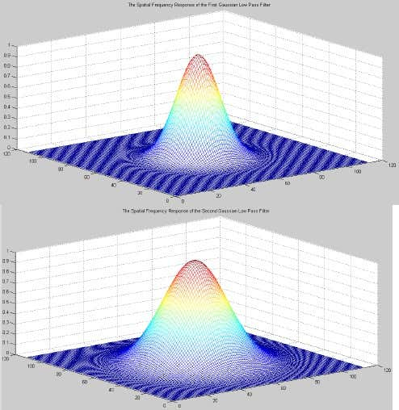

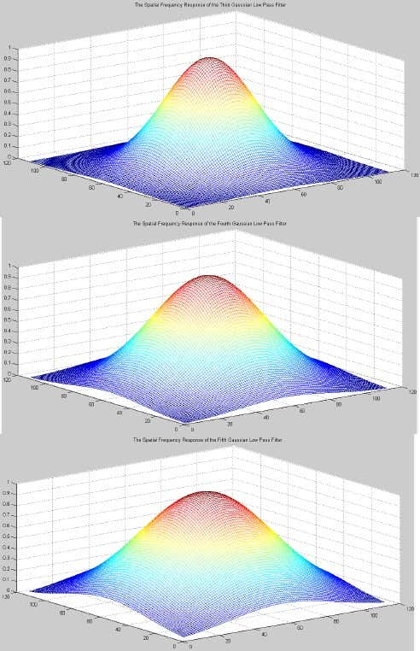

**The above figures are the Spatial Frequency Response of the First , Second, Third , Fourth and Fifth Gaussian Low Pass Filter**

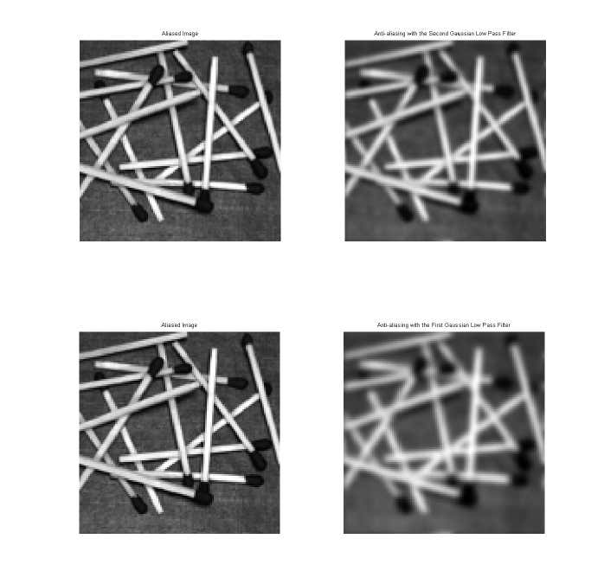

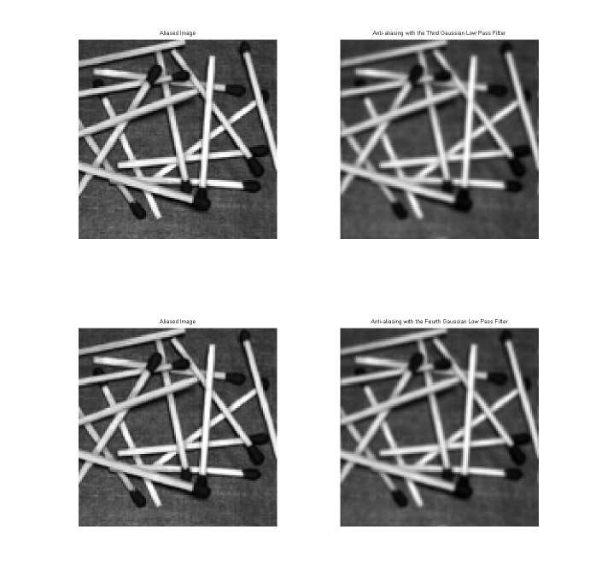

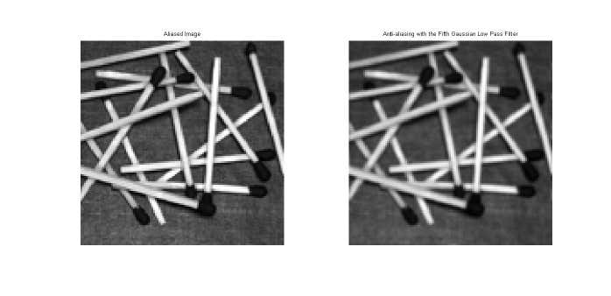

Aliased Image versus Its Anti-Aliased version with their respective Gaussian Law Pass Fliters

Median Filter

The median filter considers each pixel in the image in turn and looks at its nearby neighbours to decide whether or not it is representative of its surroundings. Instead of simply replacing the pixel value with the mean of neighbouring pixel values, it replaces it with the median of those values. The median is calculated by first sorting all the pixel values from the surrounding neighbourhood into numerical order and then replacing the pixel being considered with the middle pixel value. Since the median value is used for the neighbouring pixels, it also smoothes the image at its edges. Thus, it can also be used for the anti-aliasing procedure. Median filters with 5 different sizes are applied to the aliased image and the results are shown in the following figures

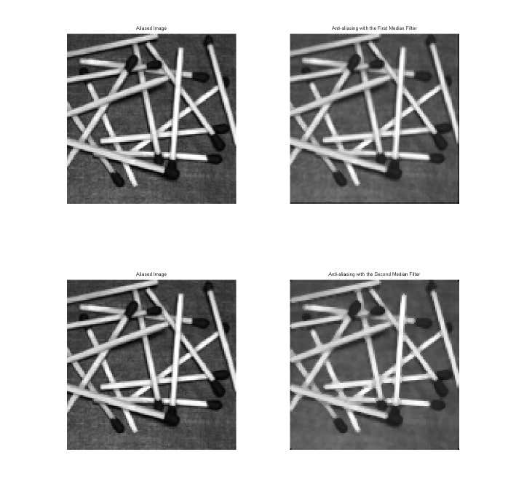

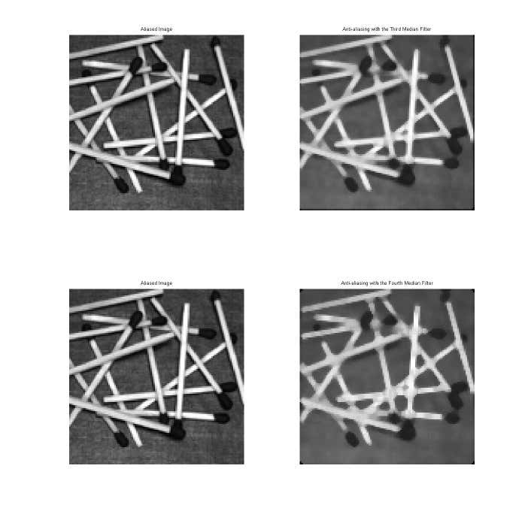

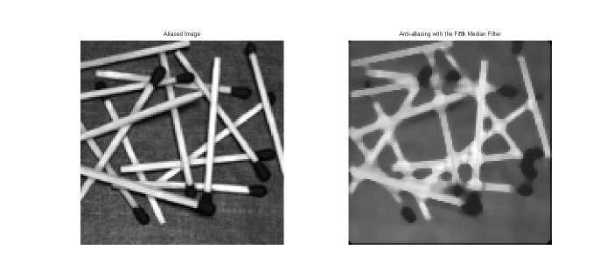

The above figures are Aliased Images versus Its Anti-Aliased Version with their respective Median Filters.

Butterworth Low Pass Filter

Butterworth low pass filter has a similar spatial frequency distribution with the Gaussian low pass filter but its high frequency components are higher than the Gaussian low pass filter preserving the high spatial frequency components higher than the Gaussian low pass filter . Butterworth low pass filters with 5 different cutoff frequencies are applied to the aliased image and the results are shown in the following figures.

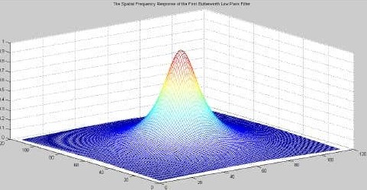

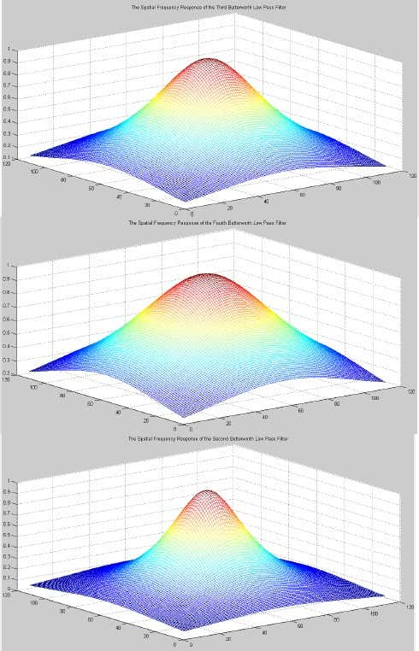

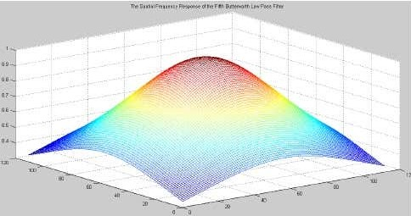

The above figures are the Spatial Frequency response of their respective Butterworth Low Pass Filter.

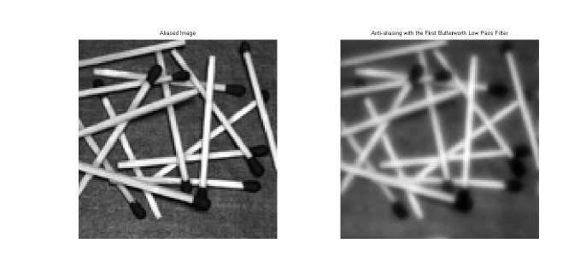

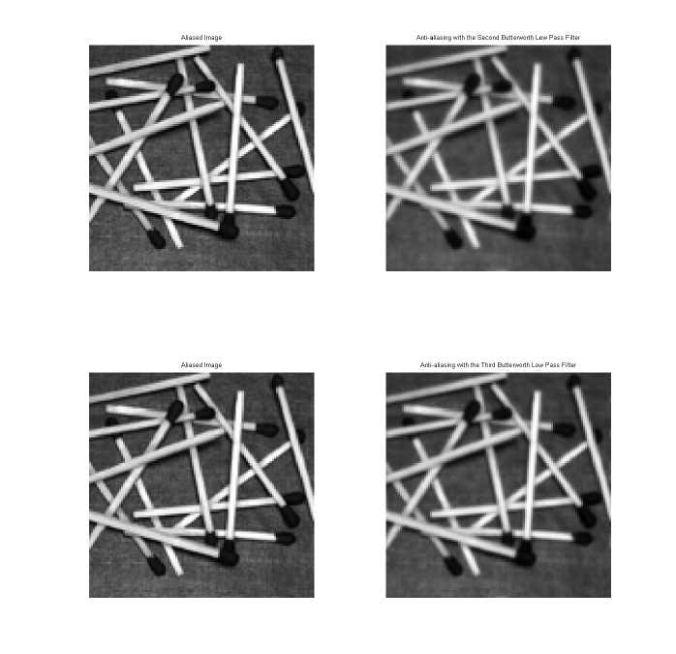

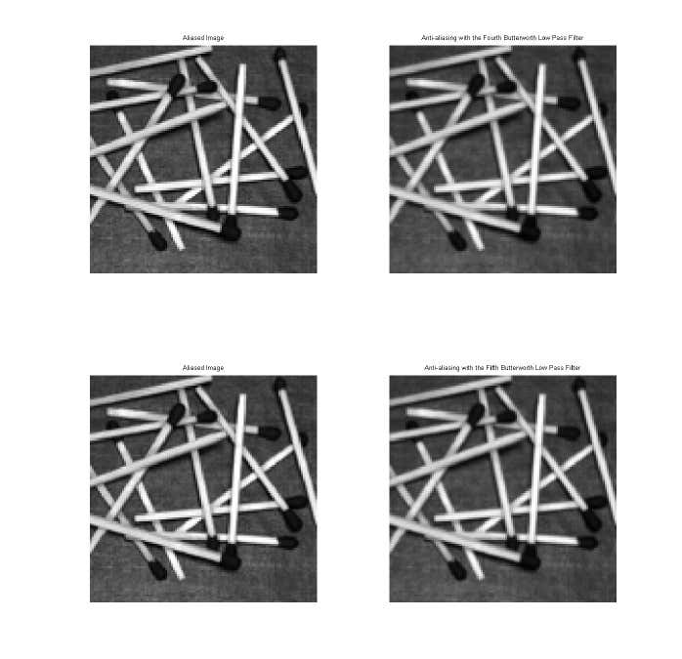

The above figures are the Aliased image versus its Anti-Aliased Version with their respective Butterworth Low Pass Filter.

Final Design

From the filters mentioned in the anti-aliasing filter design section, the third Butterworth low pass filter is chosen since it both smoothes the edges in the aliased image and preserves some of the information at higher spatial frequencies. The results are shown in detail in figures.

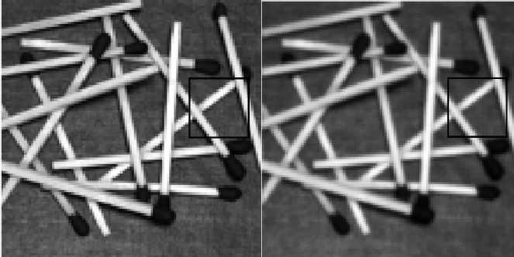

Aliased Image on the Left side and Anti-Aliased image on the right side

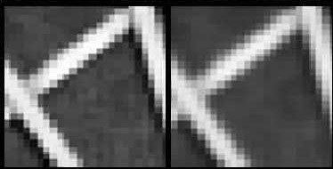

Aliased Image on the left side in detail and Anti-Aliased Image on the Right side in detail.

**Matlab Code to Calculate the Fast Fourier transform of an Image which results in the below**

Img1=imread(‘ d:\education\EE562\PROJECT\1_aliased.JPG’);

Img1=imread(‘ d:\education\EE562\PROJECT\1_antialiased.JPG’);

Img1=rgb2gray(img1);

img2=rgb2gray(img2);

figure;subplot(2,2,1);

imshow(img1);

subplot(2,2,2);

imshow(log(1+fftshift(abs(fft2(img1)))),[]);

subplot(2,2,3);

imshow(img2);

subplot(2,2,4);

imshow(log(1+fftshift(abs(fft2(img2)))),[]);

**Matlab Code for the Gaussian Low Pass Filter**

%% Anti-aliasing using Gaussian low-pass filer img=imread('D:\Education\EE562\PROJECT\Fig0807(a)(Random).tif');

img=imresize(img,0.2);

ft=fft2(img);[pft,mft]=cart2pol(real(ft),imag(ft));

[sy,sx]=size(img);

[x,y]=meshgrid(1:sx,1:sy);

forva=10:5:30mx=sx/2;my=sy/2;gaus=exp(-1/2*((x-mx).^2+(y-my).^2)/va^2);

gaus=gaus/max(gaus(:));

f=gaus;

figure;mesh(f);

mft1=f.*fftshift(mft);

mft1=ifftshift(mft1);

[re,im]=pol2cart(pft,mft1);

ft1=re+i*im;

img1=abs(ifft2(ft1));

figure;subplot(1,2,1);

imshow(img,[]);

subplot(1,2,2);

imshow(img1,[]);

end

**Matlab Code for the Median Filter**

%% Anti-aliasing using Median filer

img=imread('D:\Education\EE562\PROJECT\Fig0807(a)(Random).tif');

img=imresize(img,0.2);

ft=fft2(img);

fori=2:6img1=medfilt2(img,[i i]);

figure;subplot(1,2,1);

imshow(img,[]);

subplot(1,2,2);

imshow(img1,[]);

end

**Matlab Code for the Butterworth Low Pass Filter**

img=imread('D:\Education\EE562\PROJECT\Fig0807(a)(Random).tif');

img=imresize(img,0.2);

ft=fft2(img);

[pft,mft]= cart2pol(real(ft),imag(ft));

[sy,sx]=size(img);

rows= sx;

cols = sy;

x = (ones(rows,1) * [1:cols] - (fix(cols/2)+1))/cols;

y = ([1:rows]' * ones(1,cols) - (fix(rows/2)+1))/rows;

radius = sqrt(x.^2 + y.^2);

f = 1 ./ (1.0 + (radius ./ (0.1)).^(2*1));

figure;mesh(f);

mft1=f.*fftshift(mft);

mft1=ifftshift(mft1);

[re,im]=pol2cart(pft,mft1);

ft1=re+i*im;img1=abs(ifft2(ft1));

figure;subplot(1,2,1);

imshow(img,[]);

subplot(1,2,2);

imshow(img1,[]);

f = 1 ./ (1.0 + (radius ./ (0.2)).^(2*1));

figure;mesh(f);

mft1=f.*fftshift(mft);

mft1=ifftshift(mft1);

[re,im]=pol2cart(pft,mft1);

ft1=re+i*im;

img1=abs(ifft2(ft1));figure;

subplot(1,2,1);

imshow(img,[]);

subplot(1,2,2);

imshow(img1,[]);

f = 1 ./ (1.0 + (radius ./ (0.3)).^(2*1));

figure;mesh(f);

mft1=f.*fftshift(mft);

mft1=ifftshift(mft1);

[re,im]=pol2cart(pft,mft1);

ft1=re+i*im;

img1=abs(ifft2(ft1));

figure;subplot(1,2,1);

imshow(img,[]);

subplot(1,2,2);

imshow(img1,[]);

f = 1 ./ (1.0 + (radius ./ (0.4)).^(2*1));

figure;mesh(f);

mft1=f.*fftshift(mft);

mft1=ifftshift(mft1);

[re,im]=pol2cart(pft,mft1);

ft1=re+i*im;img1=abs(ifft2(ft1));

figure;subplot(1,2,1);

imshow(img,[]);

subplot(1,2,2);

imshow(img1,[]);

f = 1 ./ (1.0 + (radius ./ (0.5)).^(2*1)) ;

figure;mesh(f);

mft1=f.*fftshift(mft);

mft1=ifftshift(mft1);

[re,im]=pol2cart(pft,mft1);

ft1=re+i*im;

img1=abs(ifft2(ft1));

figure;subplot(1,2,1);

imshow(img,[]);

subplot(1,2,2);

imshow(img1,[]);

**CONCLUSION**

As a result , aliasing affects the high spatial frequency components. Because of that, the bandwidth o0f the image should be limited before sampling procedure by using a low pass filter.Two types of lw pass filters and median filter, which also smoothes the image, are examined in this project to be used as the anti-aliasing filter. After applying some tests,Butterworth low pass filter is determined to be used to limit the bandwidth of the image.

**REFERENCES**

1.http://cnx.org/content/m10793/latest/

2.http://www.efunda.com/designstandards/sensors/methods/dsp_aliasing.cfm

3.http://www.svi.nl/AntiAliasing

4.http://homepages.inf.ed.ac.uk/rbf/HIPR2/gsmooth.htm

5.http://homepages.inf.ed.ac.uk/rbf/HIPR2/median.htm6.http://www.cs.brown.edu/courses/cs123/lectures/image_processing_2.pdf 7.http://web.cs.wpi.edu/~matt/courses/cs563/talks/antialiasing/methods.html